

Diseño de sistemas digitales.

Practica 6: Abecedario

Adrián Emilio Vázquez Icedo

Gilberto Espinoza Maciel

22 septiembre de 2017

Hermosillo, Sonora

|  |  |  |  |  |  |  |  |  |  |  |  |  |  |  |  |  |  |  |  |  |  |
| --- | --- | --- | --- | --- | --- | --- | --- | --- | --- | --- | --- | --- | --- | --- | --- | --- | --- | --- | --- | --- | --- |
| a | b | c | d | e |  | A | B | C | D | E | F | G | H | I | J | K | L | M | N | O | P |
| 0 | 0 | 0 | 0 | 0 | A | 1 | 1 | 0 | 0 | 1 | 1 | 0 | 0 | 0 | 0 | 0 | 1 | 1 | 1 | 1 | 0 |
| 0 | 0 | 0 | 0 | 1 | B | 1 | 1 | 0 | 0 | 1 | 1 | 0 | 1 | 1 | 0 | 0 | 1 | 1 | 1 | 1 | 0 |
| 0 | 0 | 0 | 1 | 0 | C | 1 | 1 | 0 | 0 | 1 | 1 | 0 | 1 | 1 | 0 | 0 | 0 | 0 | 0 | 0 | 0 |
| 0 | 0 | 0 | 1 | 1 | D | 1 | 1 | 0 | 0 | 1 | 1 | 0 | 1 | 1 | 0 | 0 | 1 | 0 | 0 | 1 | 0 |
| 0 | 0 | 1 | 0 | 0 | E | 1 | 1 | 0 | 0 | 1 | 1 | 0 | 1 | 1 | 0 | 0 | 0 | 1 | 1 | 0 | 0 |
| 0 | 0 | 1 | 0 | 1 | F | 1 | 1 | 0 | 0 | 1 | 1 | 0 | 0 | 0 | 0 | 0 | 0 | 1 | 1 | 0 | 0 |
| 0 | 0 | 1 | 1 | 0 | G | 1 | 1 | 0 | 0 | 1 | 1 | 0 | 1 | 1 | 0 | 0 | 1 | 1 | 0 | 0 | 0 |
| 0 | 0 | 1 | 1 | 1 | H | 0 | 0 | 0 | 0 | 1 | 1 | 0 | 0 | 0 | 0 | 0 | 1 | 1 | 1 | 1 | 0 |
| 0 | 1 | 0 | 0 | 0 | I | 1 | 1 | 1 | 0 | 0 | 0 | 0 | 1 | 1 | 1 | 0 | 0 | 0 | 0 | 0 | 0 |
| 0 | 1 | 0 | 0 | 1 | J | 1 | 1 | 1 | 0 | 0 | 0 | 0 | 1 | 0 | 1 | 0 | 0 | 0 | 0 | 0 | 0 |
| 0 | 1 | 0 | 1 | 0 | K | 0 | 0 | 0 | 0 | 1 | 1 | 0 | 0 | 0 | 0 | 1 | 0 | 0 | 1 | 0 | 1 |
| 0 | 1 | 0 | 1 | 1 | L | 0 | 0 | 0 | 0 | 1 | 1 | 0 | 1 | 1 | 0 | 0 | 0 | 0 | 0 | 0 | 0 |
| 0 | 1 | 1 | 0 | 0 | M | 0 | 0 | 0 | 1 | 1 | 1 | 0 | 0 | 0 | 0 | 0 | 1 | 0 | 0 | 1 | 1 |
| 0 | 1 | 1 | 0 | 1 | N | 0 | 0 | 0 | 1 | 1 | 1 | 0 | 0 | 0 | 0 | 1 | 1 | 0 | 0 | 1 | 0 |
| 0 | 1 | 1 | 1 | 0 | O | 1 | 1 | 0 | 0 | 1 | 1 | 0 | 1 | 1 | 0 | 0 | 1 | 0 | 0 | 1 | 0 |
| 0 | 1 | 1 | 1 | 1 | P | 1 | 1 | 0 | 0 | 1 | 1 | 0 | 0 | 0 | 0 | 0 | 0 | 1 | 1 | 1 | 0 |
| 1 | 0 | 0 | 0 | 0 | Q | 1 | 1 | 0 | 0 | 1 | 1 | 0 | 1 | 1 | 0 | 1 | 1 | 0 | 0 | 1 | 0 |
| 1 | 0 | 0 | 0 | 1 | R | 1 | 1 | 0 | 0 | 1 | 1 | 0 | 0 | 0 | 0 | 1 | 0 | 1 | 1 | 1 | 0 |
| 1 | 0 | 0 | 1 | 0 | S | 1 | 1 | 0 | 0 | 1 | 0 | 0 | 1 | 1 | 0 | 0 | 1 | 1 | 1 | 0 | 0 |
| 1 | 0 | 0 | 1 | 1 | T | 1 | 1 | 1 | 0 | 0 | 0 | 0 | 0 | 0 | 1 | 0 | 0 | 0 | 0 | 0 | 0 |
| 1 | 0 | 1 | 0 | 0 | U | 0 | 0 | 0 | 0 | 1 | 1 | 0 | 1 | 1 | 0 | 0 | 1 | 0 | 0 | 1 | 0 |
| 1 | 0 | 1 | 0 | 1 | V | 0 | 0 | 0 | 0 | 1 | 1 | 1 | 0 | 0 | 0 | 0 | 0 | 0 | 0 | 0 | 1 |
| 1 | 0 | 1 | 1 | 0 | W | 0 | 0 | 0 | 0 | 1 | 1 | 1 | 0 | 0 | 0 | 1 | 1 | 0 | 0 | 1 | 0 |
| 1 | 0 | 1 | 1 | 1 | X | 0 | 0 | 0 | 1 | 0 | 0 | 1 | 0 | 0 | 0 | 1 | 0 | 0 | 0 | 0 | 1 |
| 1 | 1 | 0 | 0 | 0 | Y | 0 | 0 | 0 | 1 | 0 | 0 | 0 | 0 | 0 | 1 | 0 | 0 | 0 | 0 | 0 | 1 |
| 1 | 1 | 0 | 0 | 1 | Z | 1 | 1 | 0 | 0 | 0 | 0 | 1 | 1 | 1 | 0 | 0 | 0 | 0 | 0 | 0 | 1 |
| 1 | 1 | 0 | 1 | 0 |  | X | X | X | X | X | X | X | X | X | X | X | X | X | X | X | X |
| 1 | 1 | 0 | 1 | 1 |  | X | X | X | X | X | X | X | X | X | X | X | X | X | X | X | X |
| 1 | 1 | 1 | 0 | 0 |  | X | X | X | X | X | X | X | X | X | X | X | X | X | X | X | X |
| 1 | 1 | 1 | 0 | 1 |  | X | X | X | X | X | X | X | X | X | X | X | X | X | X | X | X |
| 1 | 1 | 1 | 1 | 0 |  | X | X | X | X | X | X | X | X | X | X | X | X | X | X | X | X |
| 1 | 1 | 1 | 1 | 1 |  | X | X | X | X | X | X | X | X | X | X | X | X | X | X | X | X |
|  |  |  |  |  |  |  |  |  |  |  |  |  |  |  |  |  |  |  |  |  |  |

Tabla con los valores lógicos de cada segmento del 16-bits display

Los distintos segmentos tienen un funcionamiento independiente de los demás, pero todos son controlados por el reloj de 5 bits, creado con flip-flop de tipo JR, estos incluyen reloj.

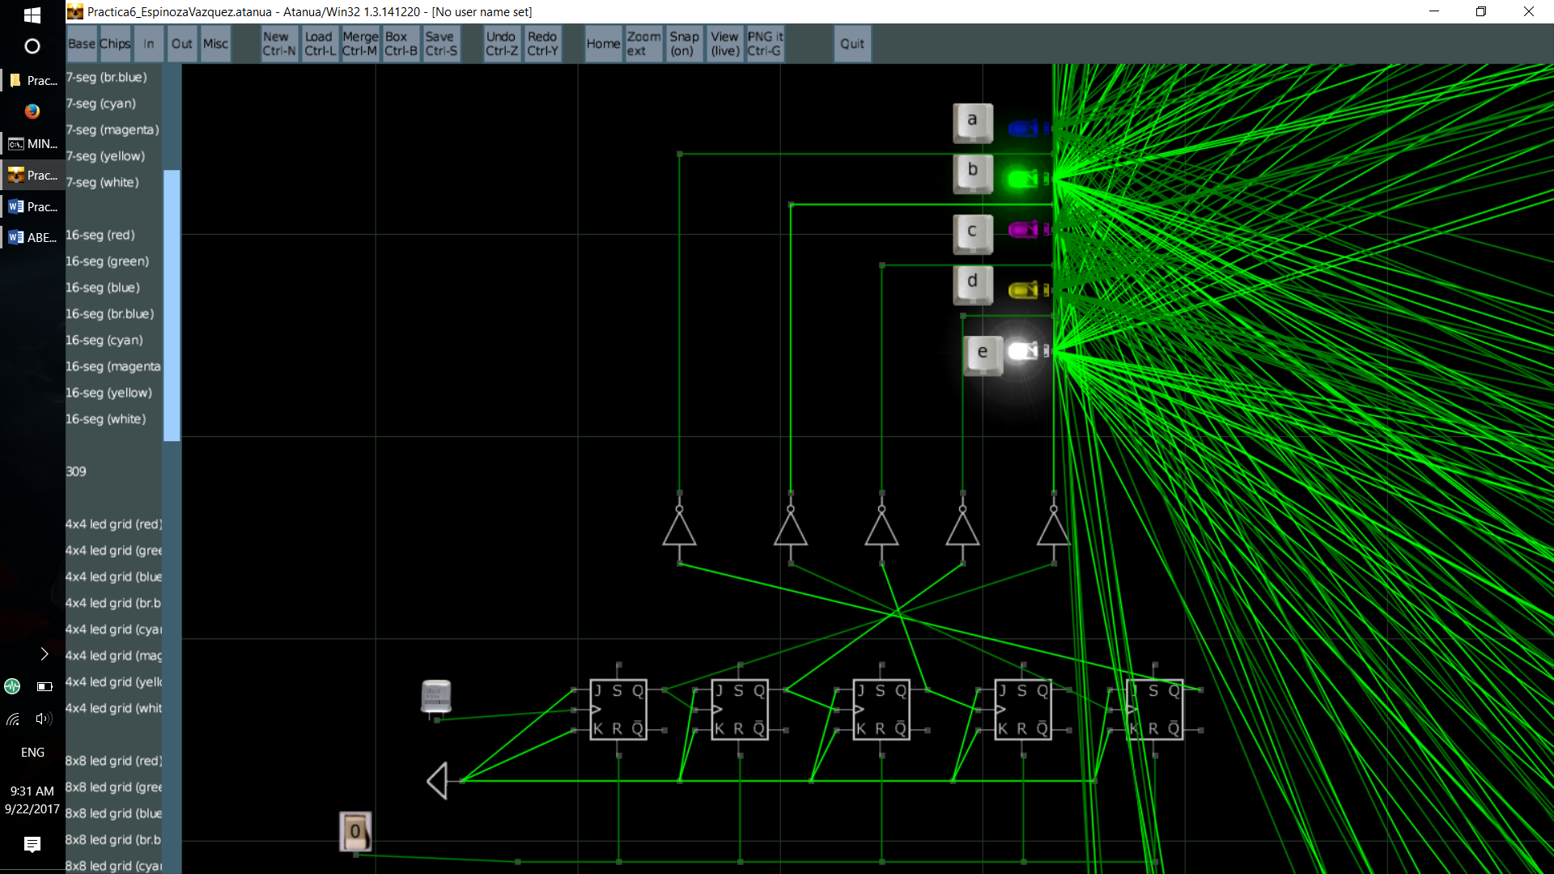

Se puede apreciar el recloj de 1Hz que marca el ritmo de cambio para el contador y el botón de reset forzoso propio del contador.

Primer segmento del lado izquierdo, nombrado ‘a’, los demás segmentos son nombrados hacia abajo.

A=( (A’B’CDE)V(A’BC’DE’)V(A’BC’DE)V(A’BCD’E’)V(A’BCD’E) V(AB’CD’E’) V(AB’CD’E) V(AB’CDE’) V(AB’CDE) V(ABC’D’E’) )’

A=( A’(B’CDE v BC’DE’ v BC’DE v BCD’E’ v BCD’E) v A(B’CD’E’ v B’CD’E v B’CDE’ v B’CDE v BC’D’E’) )’

A=( A’(B’CDE v BC’D v BCD’) v A(B’CD’ v B’CD v BC’D’E’) )’

**A =( A’(B’CDE v BC’D v BCD’) v A(B’C v BC’D’E’) )’**

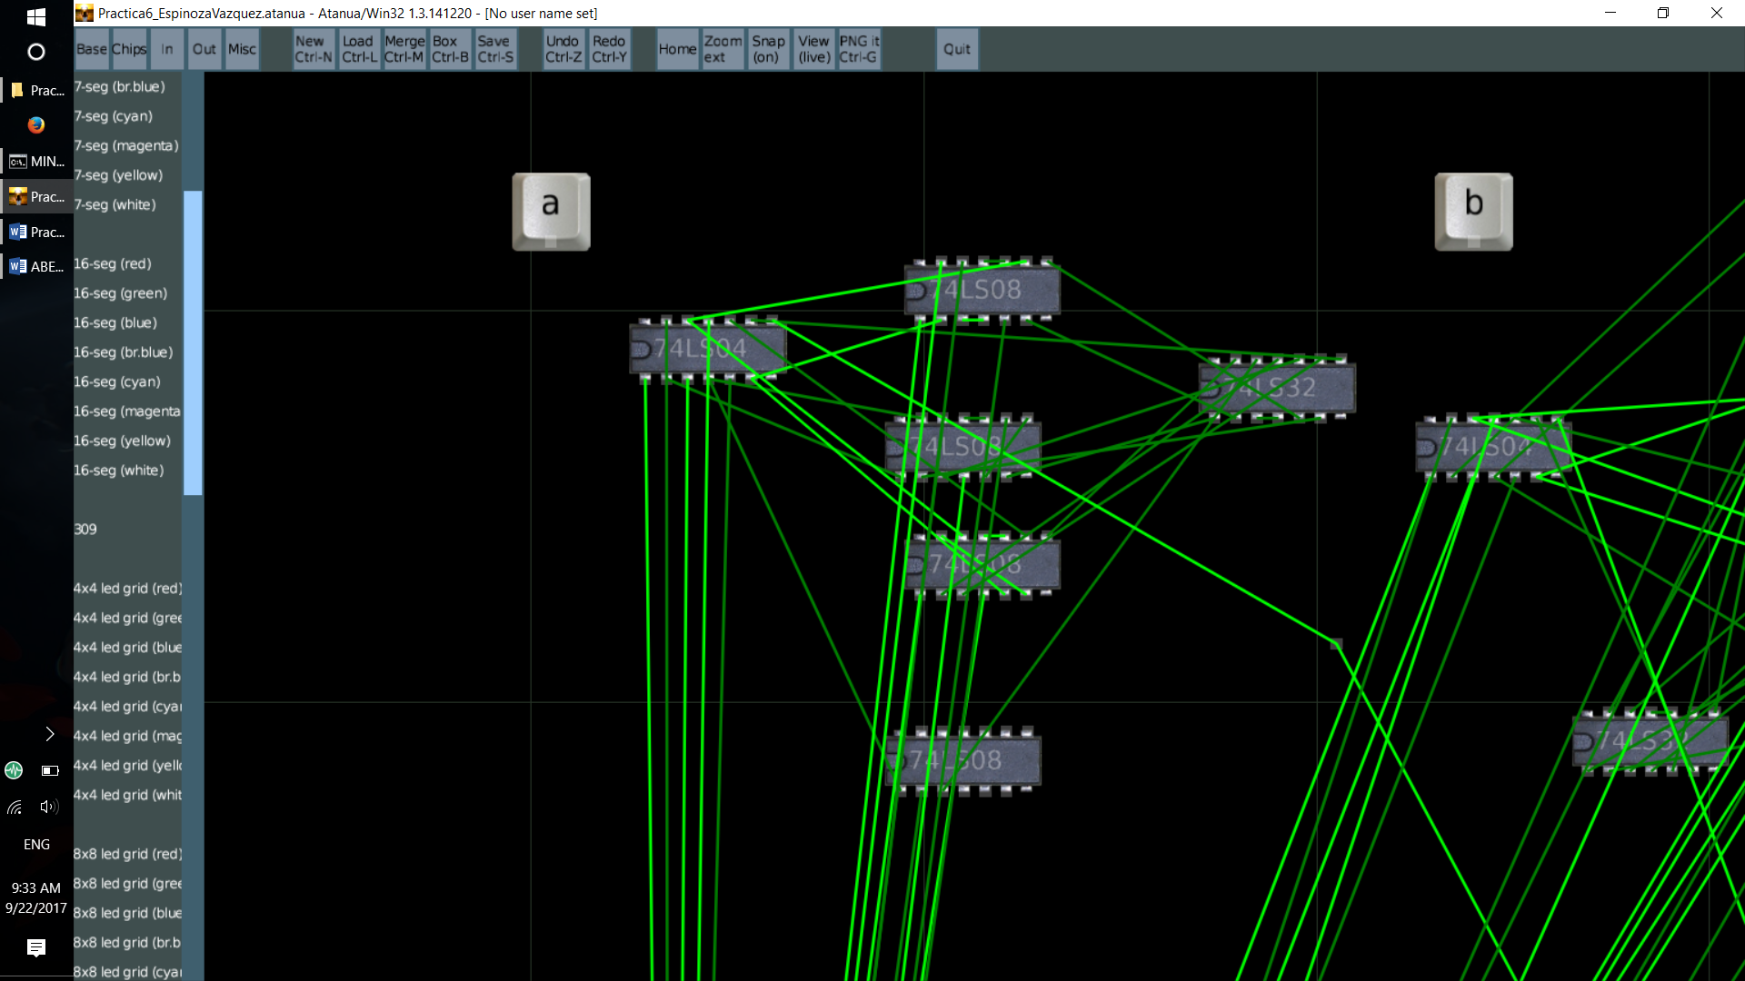

Segmento ‘b’.

B=( (A’B’CDE)V(A’BC’DE’)V(A’BC’DE)V(A’BCD’E’)V(A’BCD’E) V(AB’CD’E’) V(AB’CD’E) V(AB’CDE’) V(AB’CDE) V(ABC’D’E’) )’

B=( A’(B’CDE v BC’DE’ v BC’DE v BCD’E’ v BCD’E) v A(B’CD’E’ v B’CD’E v B’CDE’ v B’CDE v BC’D’E’) )

B=( A’(B’CDE v BC’D v BCD’) v A(B’CD’ v B’CD v BC’D’E’) )

**B=( A’(B’CDE v BC’D v BCD’) v A(B’C v BC’D’E’) )’**

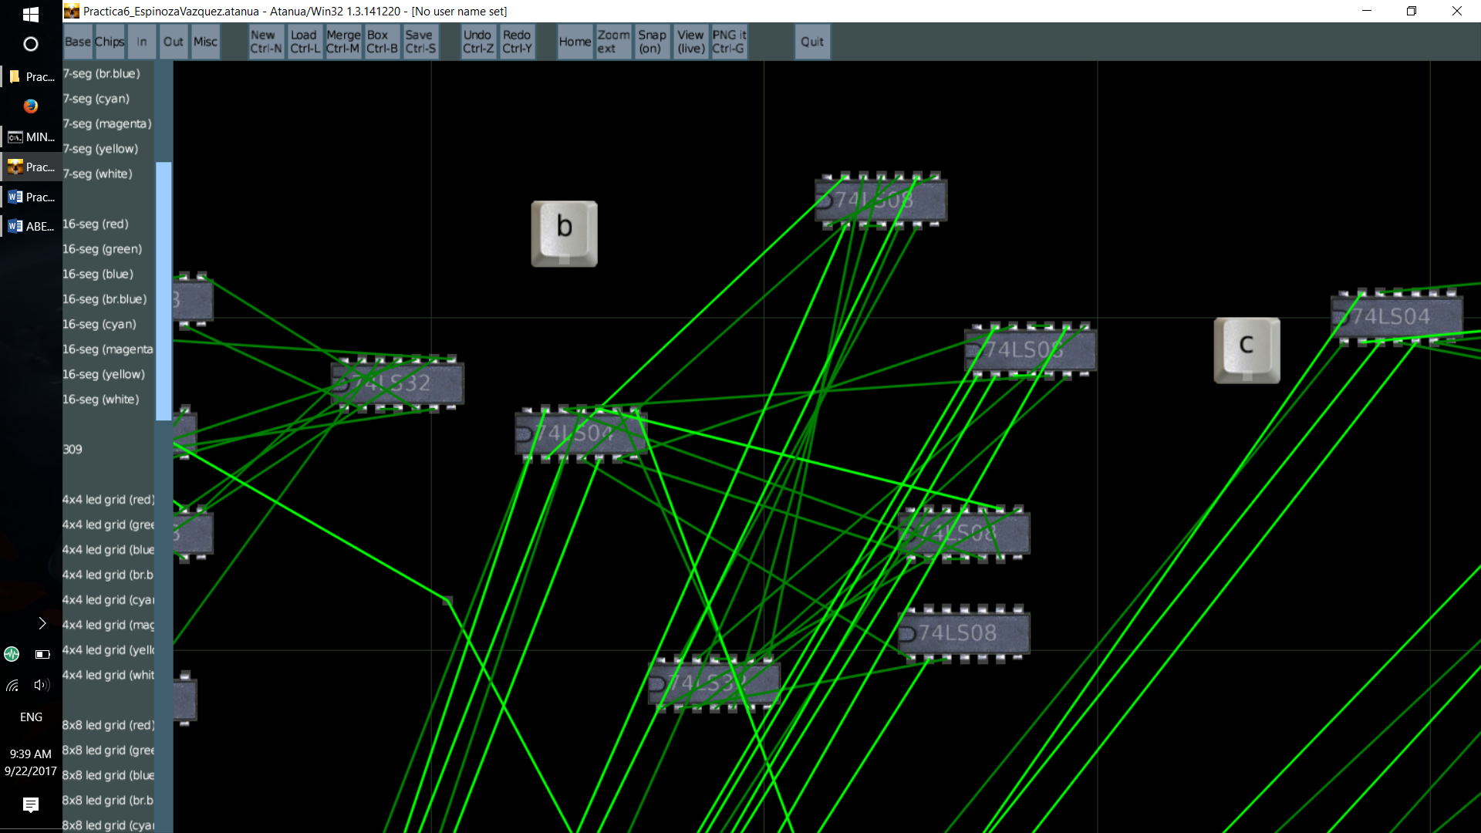

Segmento ‘c’

C=( (A’BC’D’E’)V(A’BC’D’E)V(AB’C’DE) )

**C=( A’BC’D’ v AB’C’DE )**

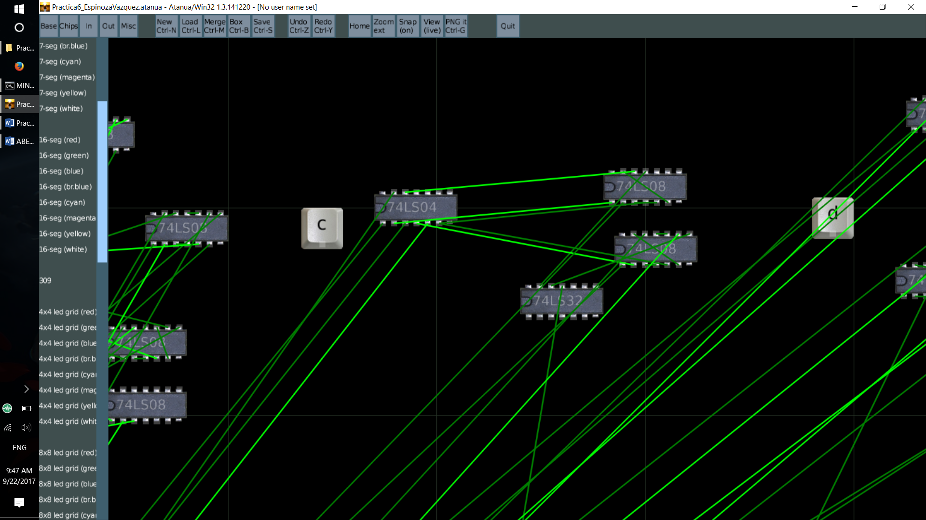

Segmento ‘d’

D=( (A’BCD’E’)v(A’BCD’E)v(AB’CDE)v(ABC’D’E’) )

**D=( A’BCD’ v A(B’CDE v BC’D’E’) )**

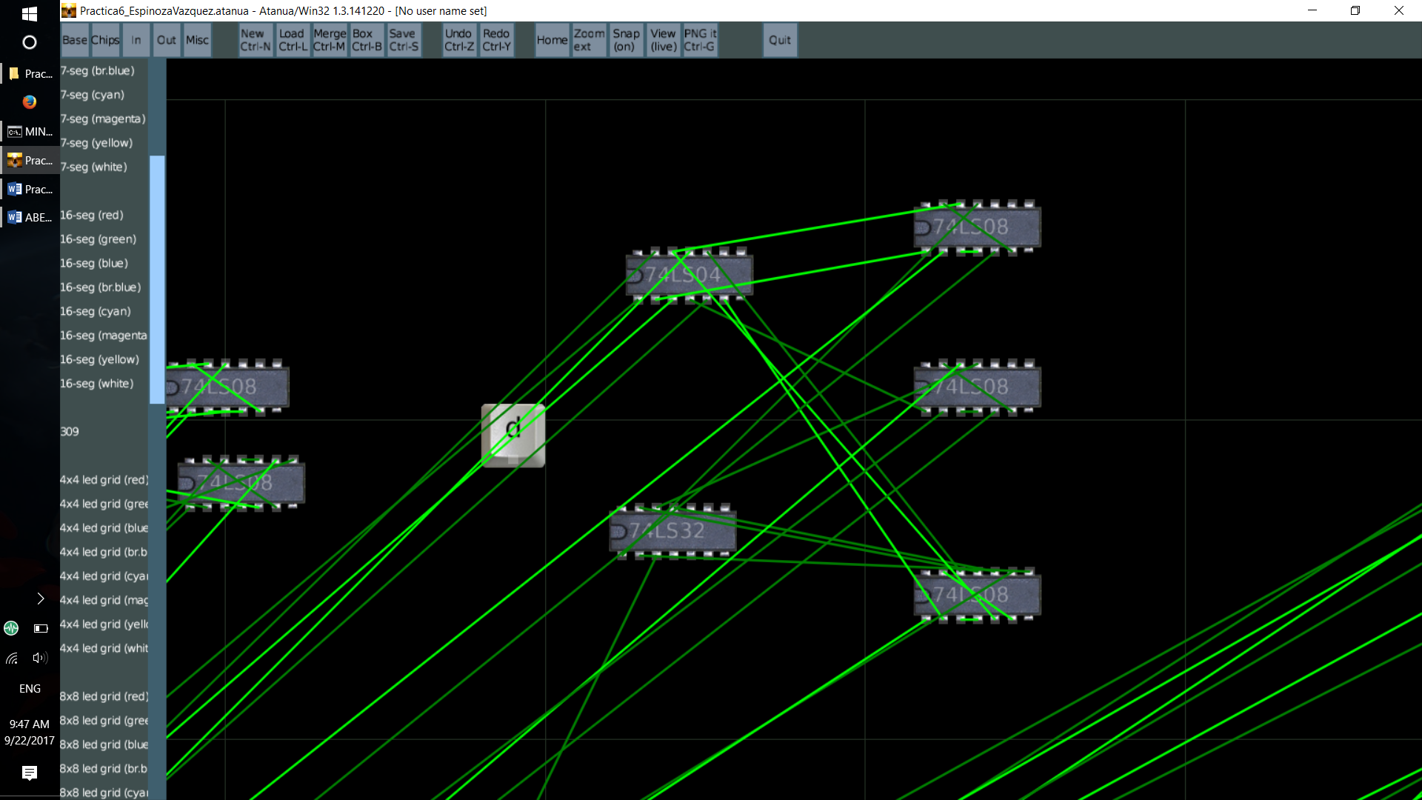

Segmento ‘e’

E=( (A’BC’D’E’)v(A’BC’D’E)v(AB’C’DE)v(AB’CDE)v(ABC’D’E’)v(ABC’D’E) )’

**E=( A’BC’D’ v A(B’DE v BC’D’) )’**

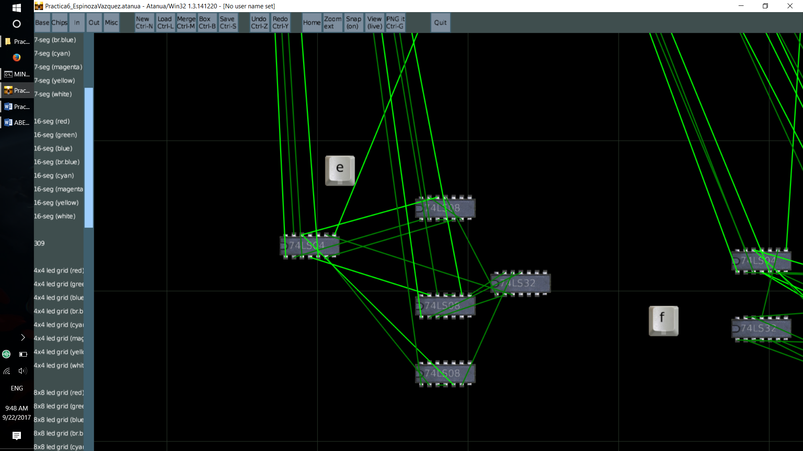

Segmento ‘f’

F=( (A’BC’D’E’)v(A’BC’D’E)v(AB’C’DE’)v(AB’C’DE)v(AB’CDE)v(ABC’D’E’)v(ABC’D’E) )’

**F=( A’BC’D’ v A(B’C’D v B’CDE v BC’D’) )**

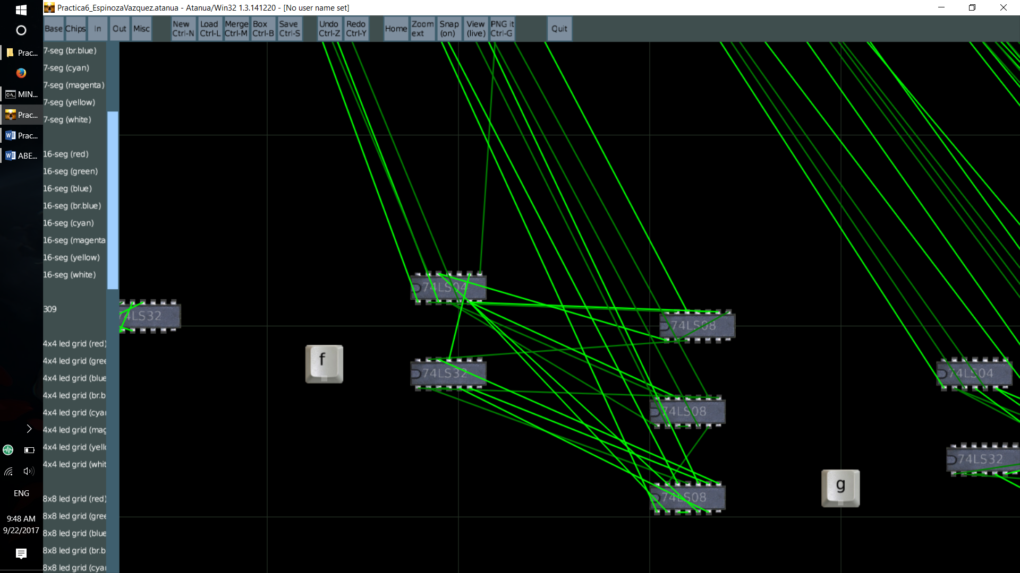

Segmento ‘g’

G=( (AB’CD’E)v(AB’CDE’)v(AB’CDE)v(ABC’D’E) )

**G=( A(B’CD’E v B’CD v BC’D’E) )**

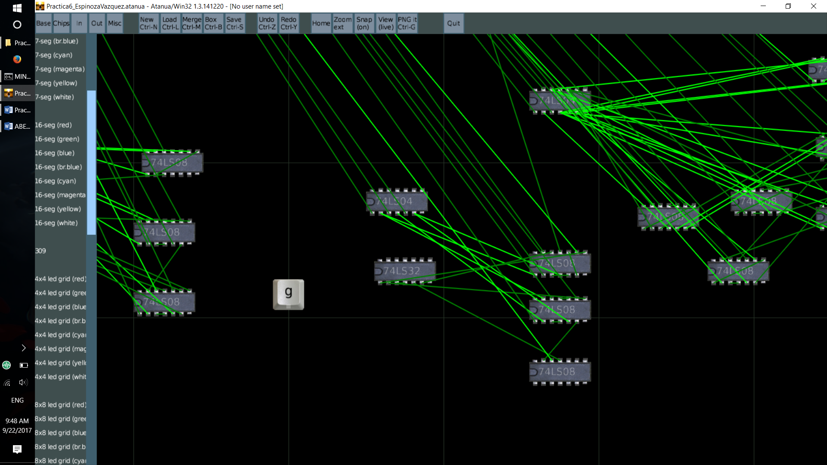

Segmento ‘h’

H=( (A’B’C’D’E)v(A’B’C’DE’)v(A’B’C’DE)v(A’B’CD’E’)v(A’B’CDE’)v(A’BC’D’E’)v(A’BC’D’E)v(A’BC’DE)v (A’BCDE’)v(AB’C’D’E’)v(AB’C’DE’)v(AB’CD’E’)v(ABC’D’E) )

H=( A’(B’C’D’E v B’C’DE’ v B’C’DE v B’CD’E’ v B’CDE’ v BC’D’E’ v BC’D’E v BC’DE v BCDE’) v A(B’C’D’E’ v B’C’DE’ v B’CD’E’ v BC’D’E) )

**H=( A’(B’C’D’E v B’C’D v B’CE’ v BC’D’ v BC’DE v BCDE’) v A(B’C’E’ v B’CD’E’ v BC’D’E) )**

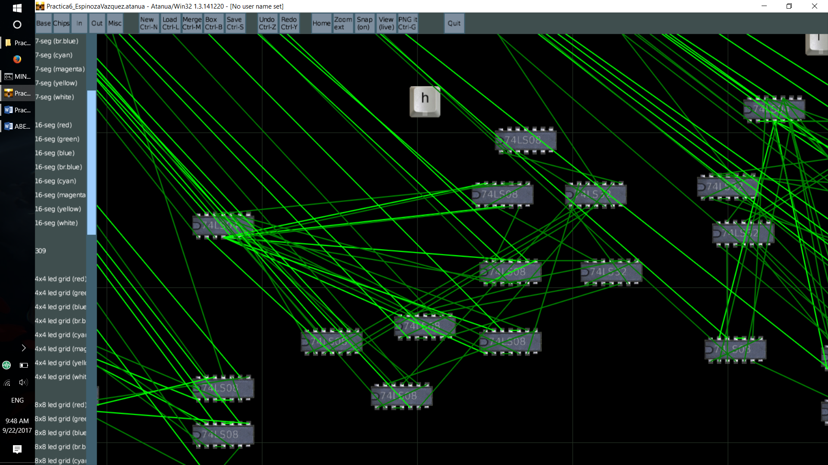

Segmento ‘i’

I=( (A’B’C’D’E)v(A’B’C’DE’)v(A’B’C’DE)v(A’B’CD’E’)v(A’B’CDE’)v(A’BC’D’E’)v(A’BC’DE)v(A’BCDE’)v (AB’C’D’E’)v(AB’C’DE’)v(AB’CD’E’)v(ABC’D’E) )

I=( A’(B’C’D’E v B’C’DE’ v B’C’DE v B’CD’E’ v B’CDE’ v BC’D’E’ v BC’DE v BCDE’) v A(B’C’D’E’ v B’C’DE’ v B’CD’E’ v BC’D’E) )

**I=( A’(B’C’D’E v B’C’D v B’CE’ v BC’D’E’ v BC’DE v BCDE’) v A(B’C’E’ v B’CD’E’ v BC’D’E) )**

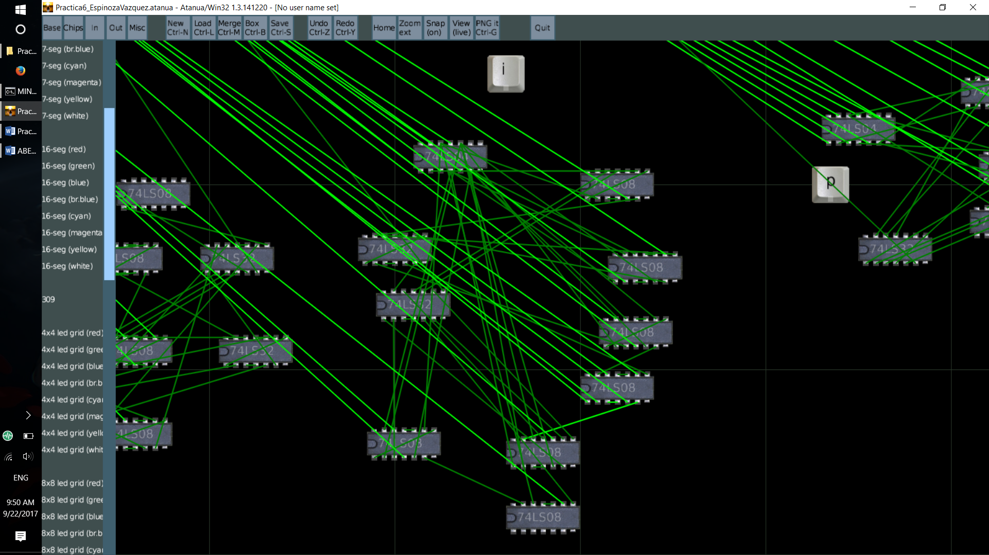

Segmento ‘j’

J=( (A’BC’D’E’)v(A’BC’D’E)v(AB’C’DE)v(ABC’D’E’) )

**J=( A’BC’D’ v A(B’C’DE v BC’D’E’) )**

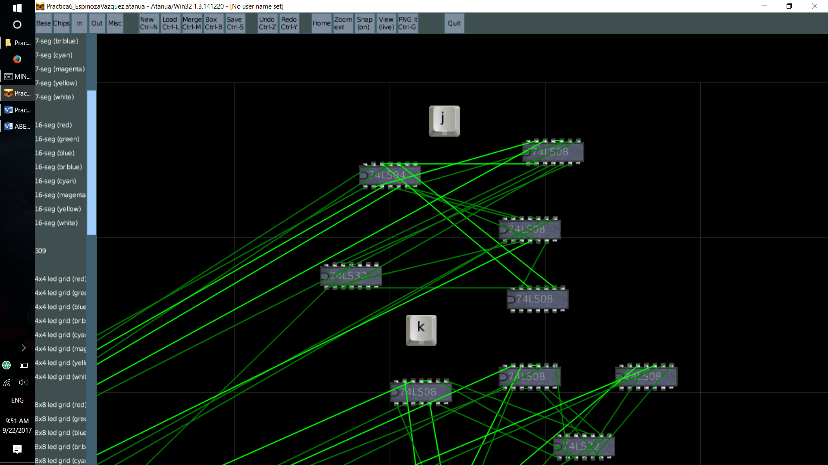

Segmento ‘k’

K=( (A’BC’DE’)v(A’BCD’E)v(AB’C’D’E’)v(AB’C’D’E)v(AB’CDE’)v(AB’CDE) )

**K=( A’B(C’DE’ v CD’E) v AB’(C’D’ v CD) )**

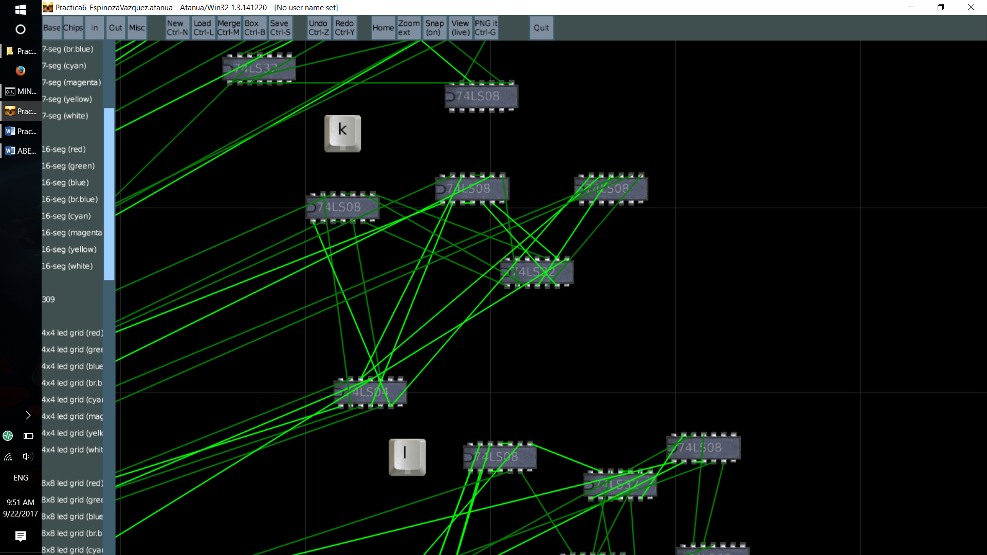

Segmento ‘l’

L=( (A’B’C’D’E’)v(A’B’C’D’E)v(A’B’C’DE)v(A’B’CDE’)v(A’B’CDE)v(A’BCD’E’)v(A’BCD’E)v(A’BCDE’)v (AB’C’D’E’)v(AB’C’DE’)v (AB’CD’E’)v(AB’CDE’) )

L=( A’B’C’D’ v A’B’C’DE v A’B’CD v A’BCD’ v A’BCDE’ v AB’C’E’ v AB’CE’)

**L=( A’(B’C’D’ v B’C’DE v B’CD v BCD’ v BCDE’) v AB’E’ )**

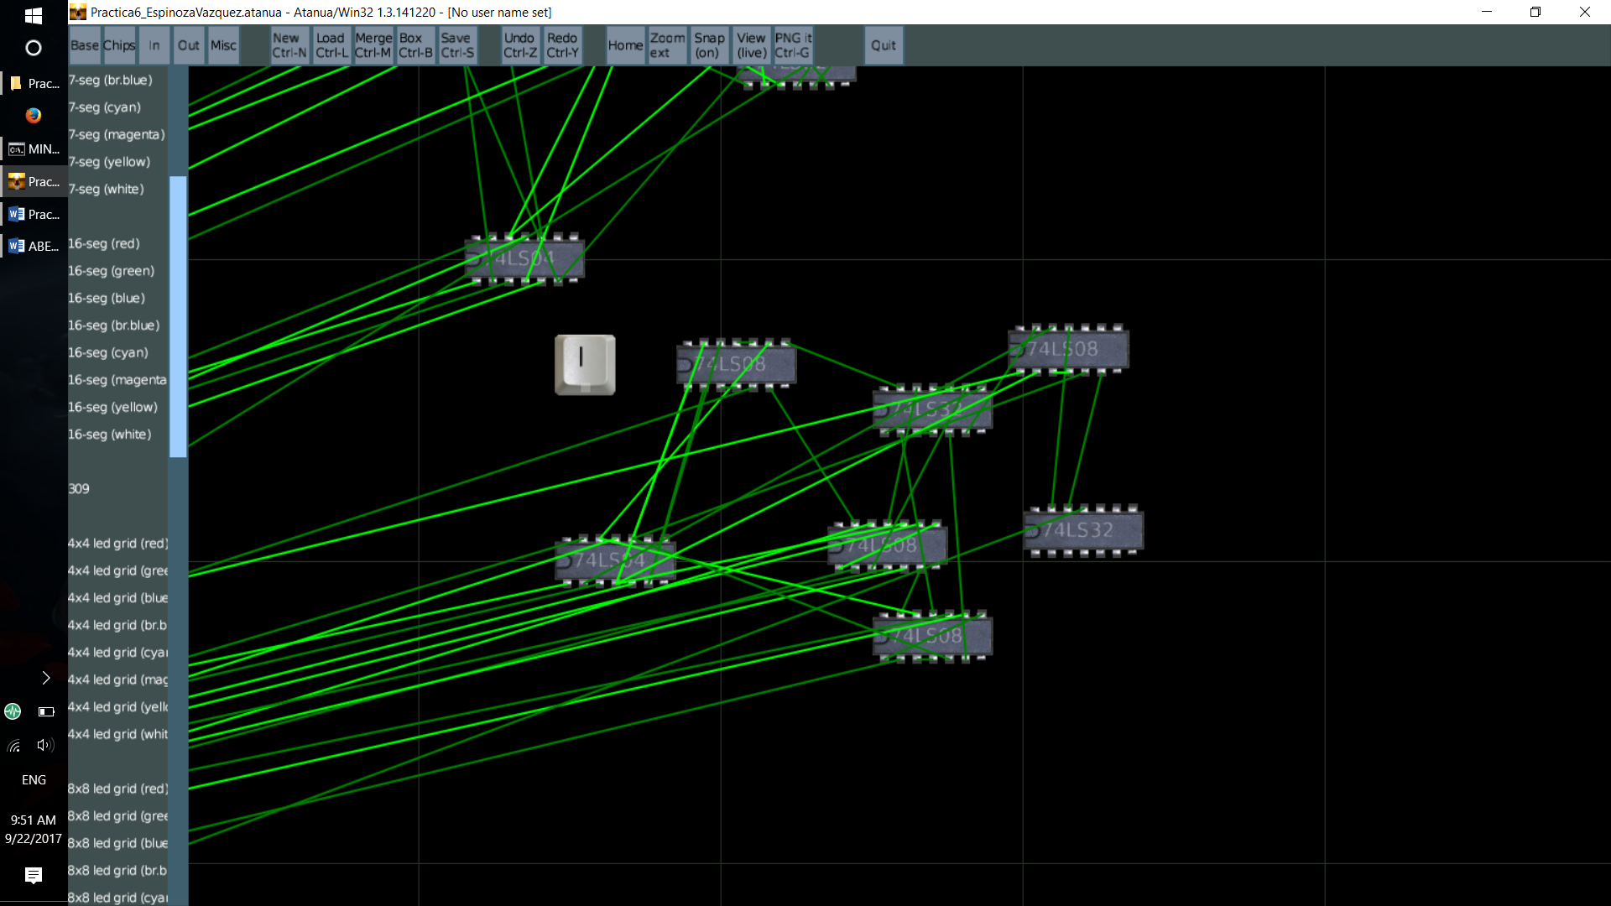

Segmento ‘m’

M=( (A’B’C’D’E’)v(A’B’C’D’E)v(A’B’CD’E’)v(A’B’CD’E)v(A’B’CDE’)v(A’B’CDE)v(A’BCDE)v(AB’C’D’E)v (AB’C’DE’) )

M=( A’B’C’D’ v A’B’CD’ v A’B’CD v A’BCDE v AB’C’(D’E v DE’) )

**M=( A’(B’D’ v B’CD v BCDE) v AB’C’(D’E v DE’) )**

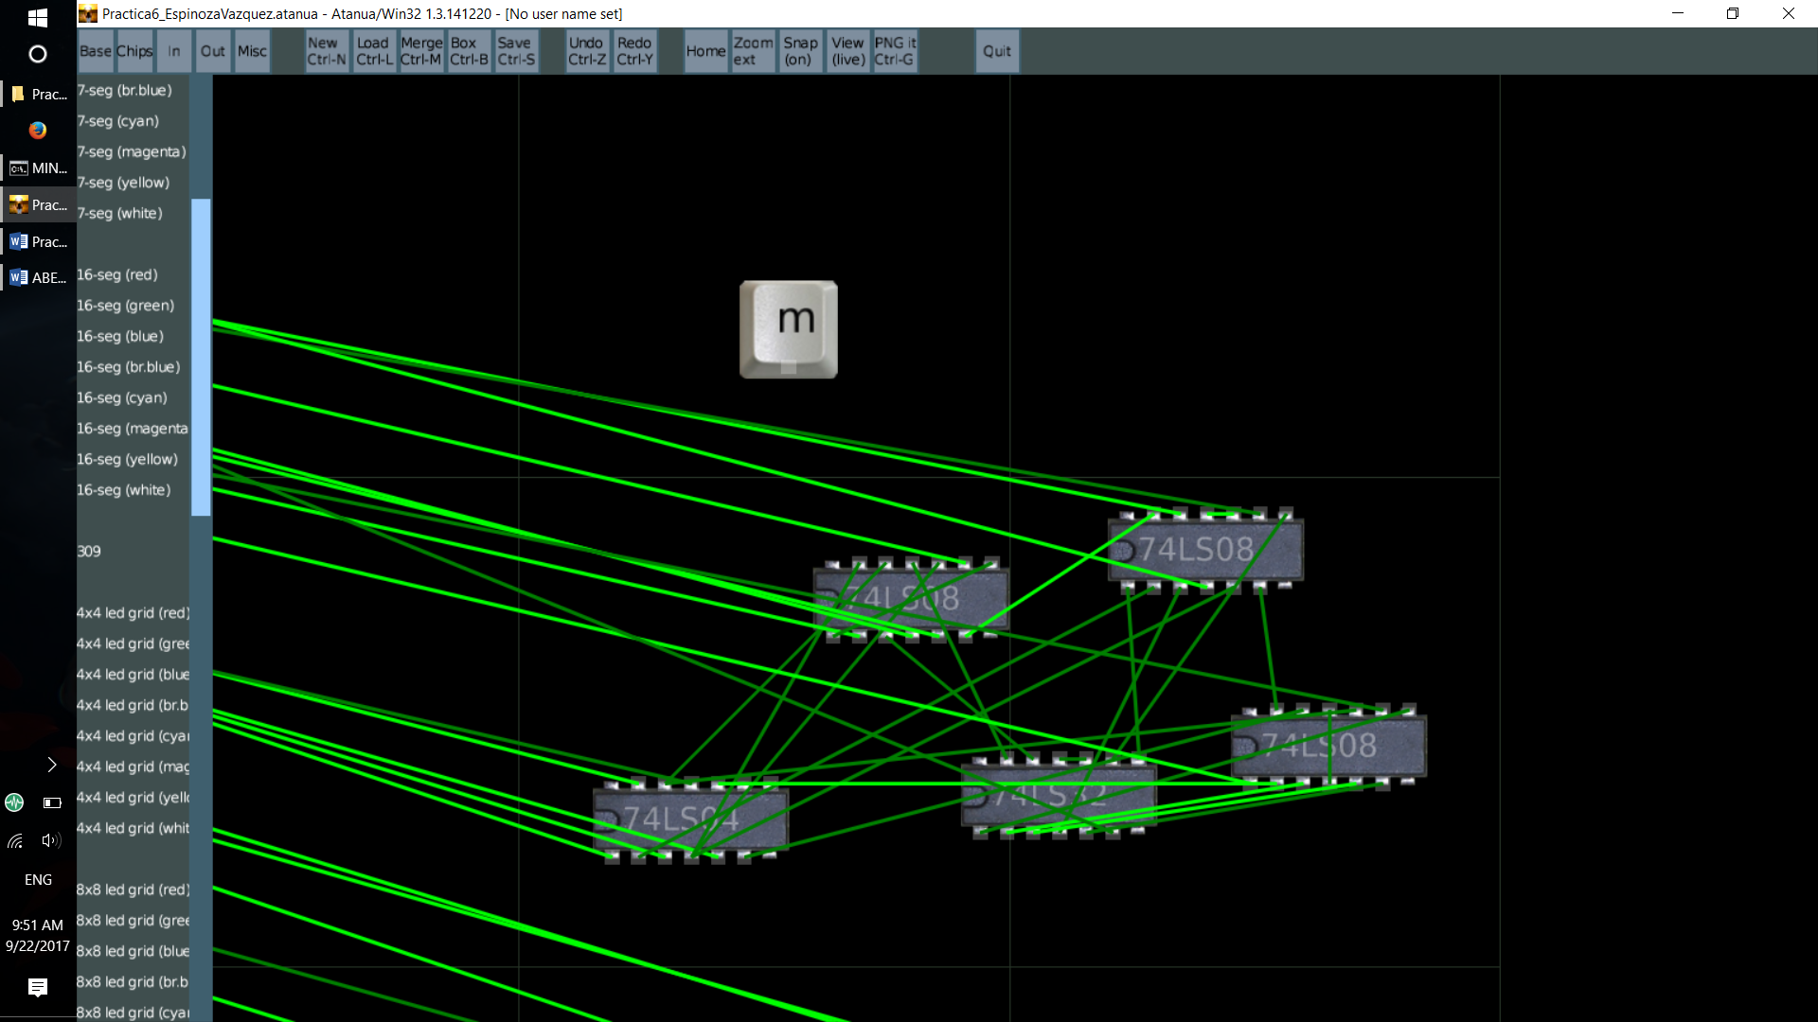

Segmento ‘n’

N=( (A’B’C’D’E’)v(A’B’C’D’E)v(A’B’CD’E’)v(A’B’CD’E)v(A’B’CDE)v(A’BC’DE’)v(A’BCDE)v(AB’C’D’E)v (AB’C’DE’) )

N=( A’B’C’D’ v A’B’CD’ v A’B’CDE v A’BC’DE’ v A’BCDE v AB’C’D’E v AB’C’DE’ )

**N=( A’(B’D’ v CDE v BC’DE’) v AB’C’(D’E v DE’) )**

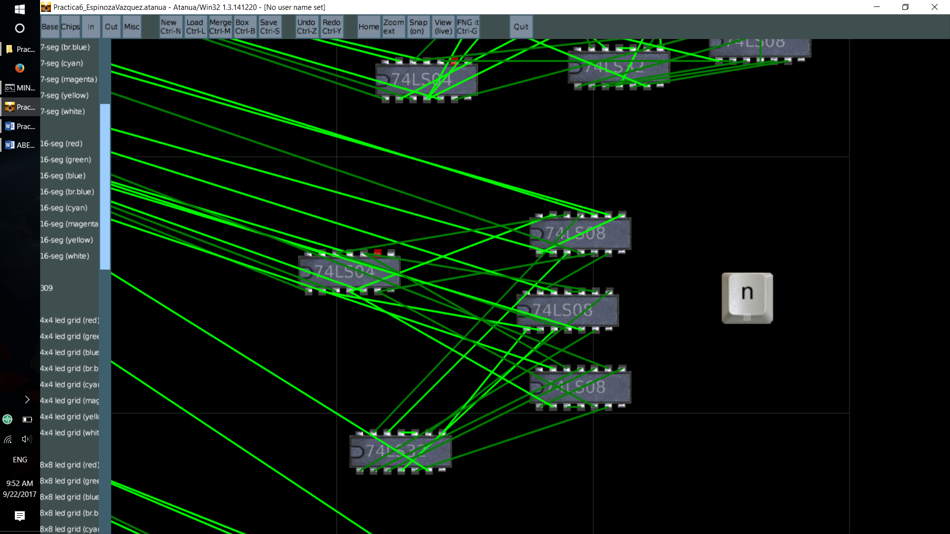

Segmento ‘o’

O=( (A’B’C’D’E’)v(A’B’C’D’E)v(A’B’C’DE)v(A’B’CDE)v(A’BCD’E’)v(A’BCD’E)v(A’BCDE’)v(A’BCDE)v (AB’C’D’E’)v(AB’C’D’E)v(AB’CD’E’)v(AB’CDE’) )

O=( A’(B’C’D’E’ v B’C’D’E v B’C’DE v B’CDE v BCD’E’ v BCD’E v BCDE’ v BCDE) v A(B’C’D’E’ v B’C’D’E v B’CD’E’ v B’CDE’ ) )

**O=( B’C’D’ v A’( B’DE v BC) v AB’CE’ )**

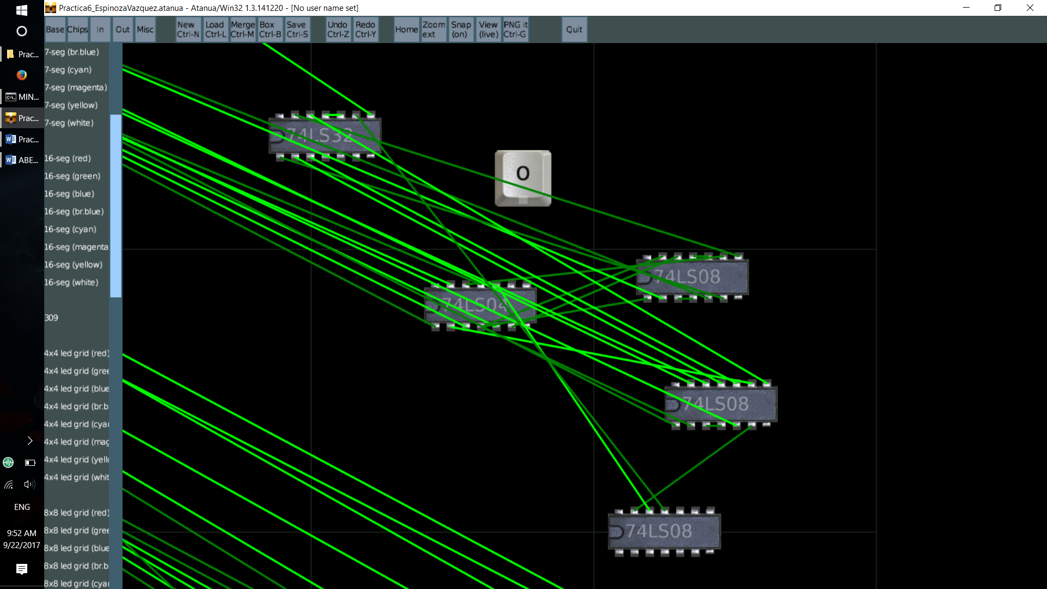

Segmento ‘p’

P=( (A’BC’DE’)v(A’BCD’E’)v(AB’CD’E)v(AB’CDE)v(ABC’D’E’)v(ABC’D’E) )

P=( A’BE’(C’D v CD’) v A(B’CD’E v B’CDE v BC’D’E’ v BC’D’E) )

**P=( A’BE’(C’D v CD’) v A(B’CE v BC’D’) )**

